Report: Analysis of Environmental and Energy Indicators Across Countries

STUDENT NAME:
STUDENT ID:
GIT LINK:
Dataset reference: https://databank.worldbank.org/source/sustainable-energy-for-all#

Abstract:
This report uses an analysis of land use, urbanization, and electricity production to look at global environmental and energy trends from 1990 to 2020. Correlation heatmaps illustrate how energy sources and consumers are changing, and line plots show how the US and UK's patterns of electricity production are shifting. Ten countries' land usage is examined in bar charts. Changes towards sustainability are evident, with a focus on the intricate dynamics of energy transitions and their effects on the environment.

The following are the reasons for selecting the topic:
Environmental sustainability, energy production, and urbanization trends are becoming increasingly important global concerns. It provides valuable insight into a country's energy infrastructure, environmental policies, and overall development if you know how each contributes to and is affected by these factors.
Heatmap Analysis of Correlations:
The analysis examines the relationships between energy sources in the UK and the US, using heatmaps to visually represent correlation coefficients between coal, oil, nuclear, natural gas, hydroelectric, and gas. The heatmaps focus on urban population statistics and electricity production sources, with each square representing the correlation coefficient. The results show that natural gas and oil have a positive relationship with electricity production in the US and the UK, while varying correlations exist between other forms of energy and nuclear power, suggesting a range of energy sources. The two sets of graphs offer unique perspectives on selected indicators across national boundaries.

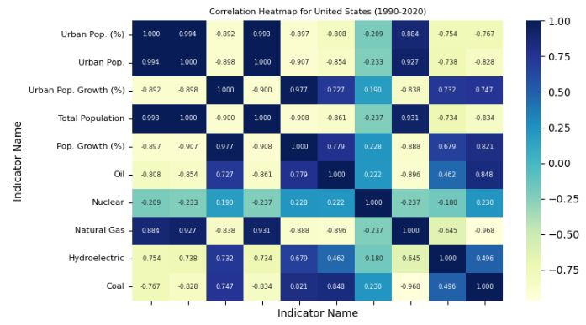 | 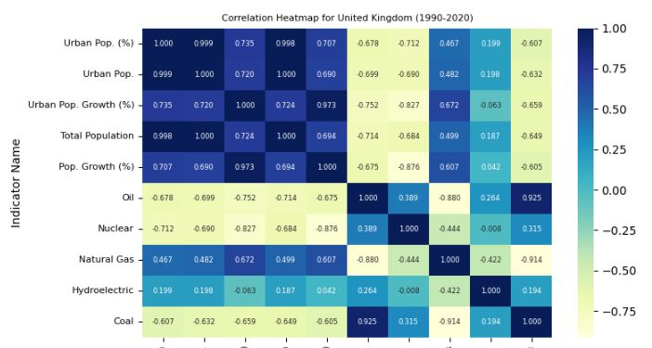
The two correlation heatmaps reveal changes in energy and socioeconomic trends over the past three decades. The first heatmap shows an inverse relationship between coal-based electricity production and urbanization, increasing from 195.9 million in 1990 to 347.2 million in 2020. The second heatmap shows a shift away from oil-based electricity production, a positive correlation between urbanization and natural gas-based electricity production, and a decline in coal production. The region's population increased gradually during these shifts, highlighting the complex relationship between population growth and sustainable energy practices.

Line plots displaying comparative trends in electricity production:
We also explore the patterns of electricity production in the UK and the US. The % contributions from each energy source from 1990 to 2020 are shown in line charts. Principal discoveries consist of the amount of electricity produced in the US from coal has been steadily declining, with natural gas and renewable energy sources coming in to take its place. In the UK, the amount of renewable energy produced has increased significantly while the amount of coal used has decreased.
The United States' energy landscape has evolved towards a diversified mix, with natural gas playing a prominent role (41% in 2020), alongside renewables like wind and solar. Coal's share has significantly reduced from 54% in 1990 to 20% in 2020. The United Kingdom, historically more dependent on coal, has seen a significant decline from 67% in 1990 to 31% in 2020. The UK has intensified its focus on natural gas and renewables, with a remarkable increase in renewables from 2% in 1990 to 9% in 2020. Both countries share a commitment to reducing fossil fuel dependence, showcasing the complex dynamics of global energy transitions.

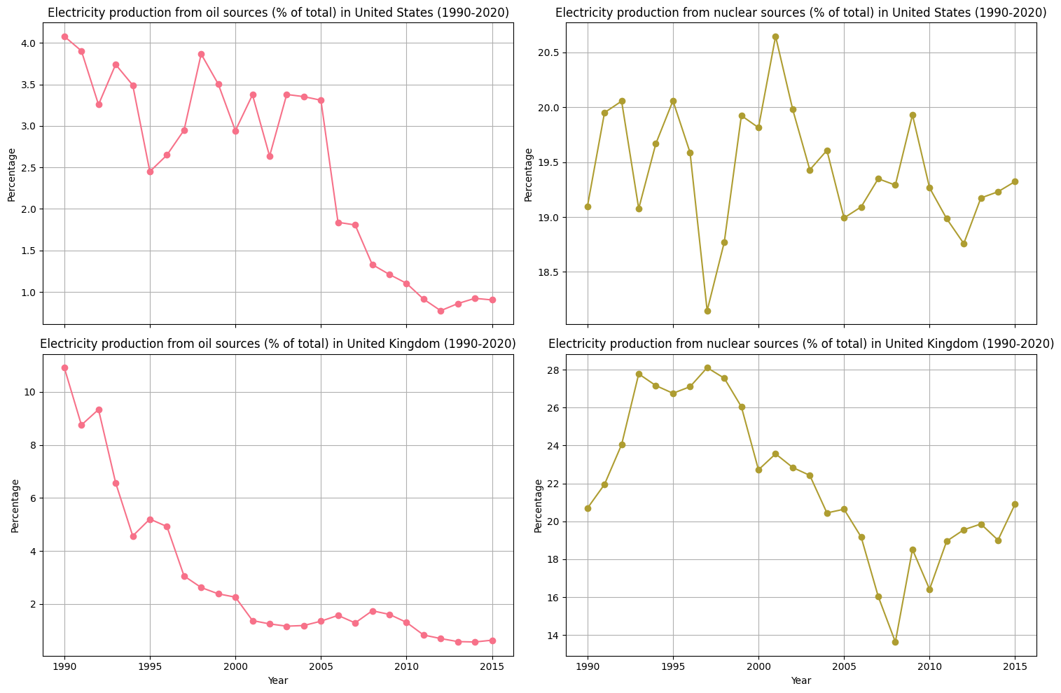
Bar Chart Analysis of Land Usage Indicators:
The Bar plots study the environmental impact of land use in ten countries, including the US, UK, China, India, Saudi Arabia, Brazil, Russia, Germany, Japan, and Australia. The data is based on 2018 land indicators. Australia and Russia have higher forest area percentages, while Saudi Arabia has a lower percentage due to its arid climate. Brazil and Russia allocate significant portions to agriculture, while Japan and Germany have a smaller percentage due to industrialization. Understanding these patterns is crucial for informed environmental.
The graph shows the forest area and agricultural land percentages in Australia and Brazil from 1990 to 2020. Australia has a higher percentage of forest area, with 63.2%, compared to 56.1% in Brazil. However, both countries have experienced a decrease in forest area over the past three decades. Brazil has a higher percentage of agricultural land, with 42.6%, compared to 55% in Australia. These differences are attributed to factors like climate, economic development, and population growth. The decline in forest area and increase in agricultural land have environmental and social impacts.
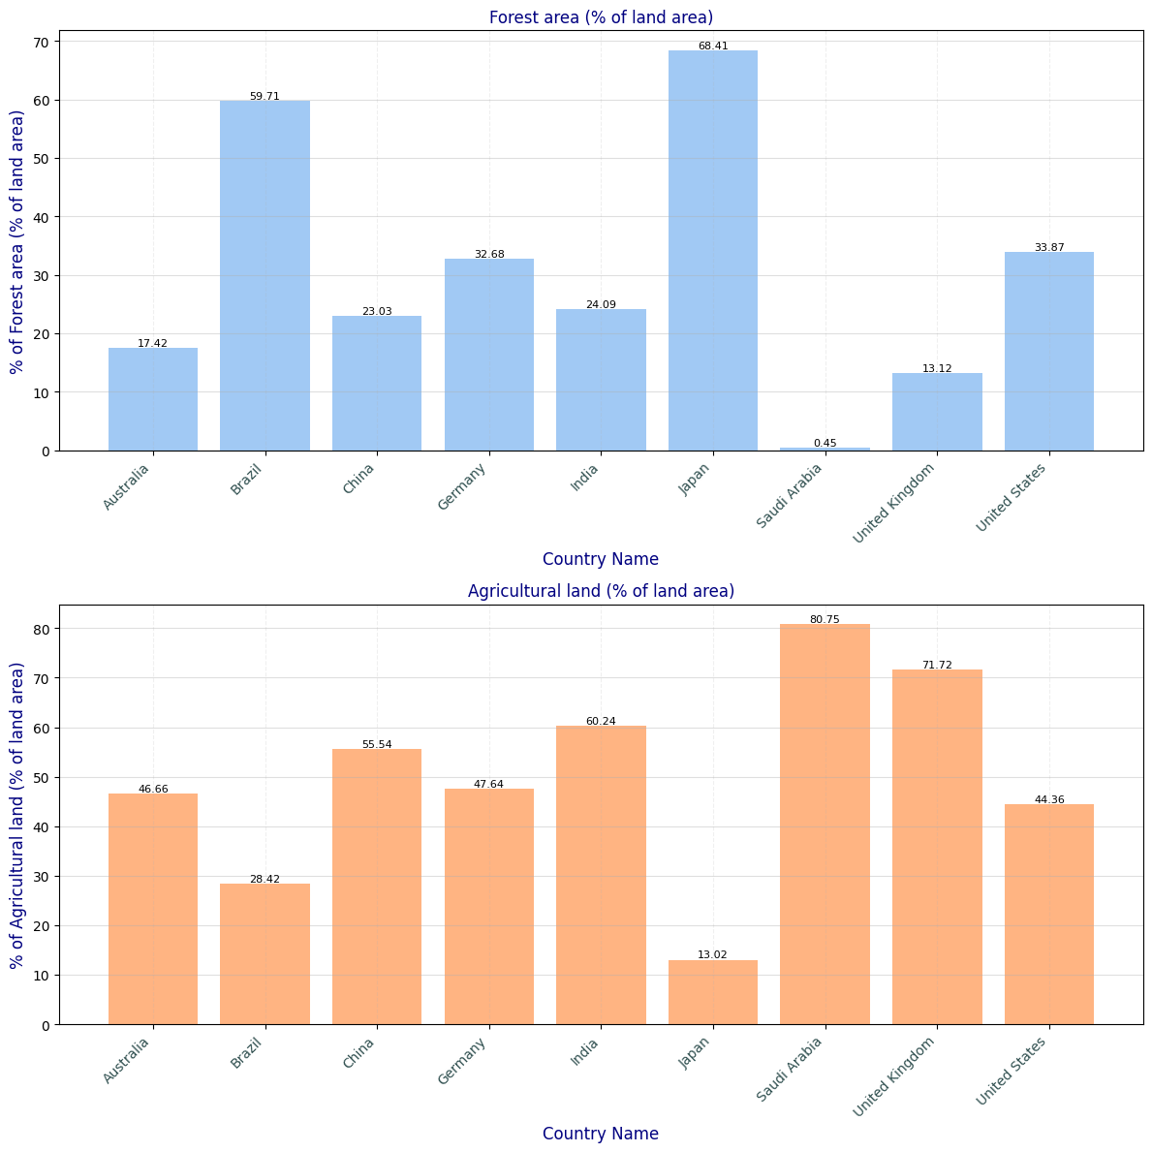
Conclusion:
To sum up, this thorough examination highlights how the world's patterns of land use, urbanization, and energy production are changing. The observed shifts in the production of electricity towards sustainability emphasise the need for well-informed policies. To achieve sustainable development that is environmentally conscious, it is imperative to continue paying attention to the complex dynamics of energy transitions.

